[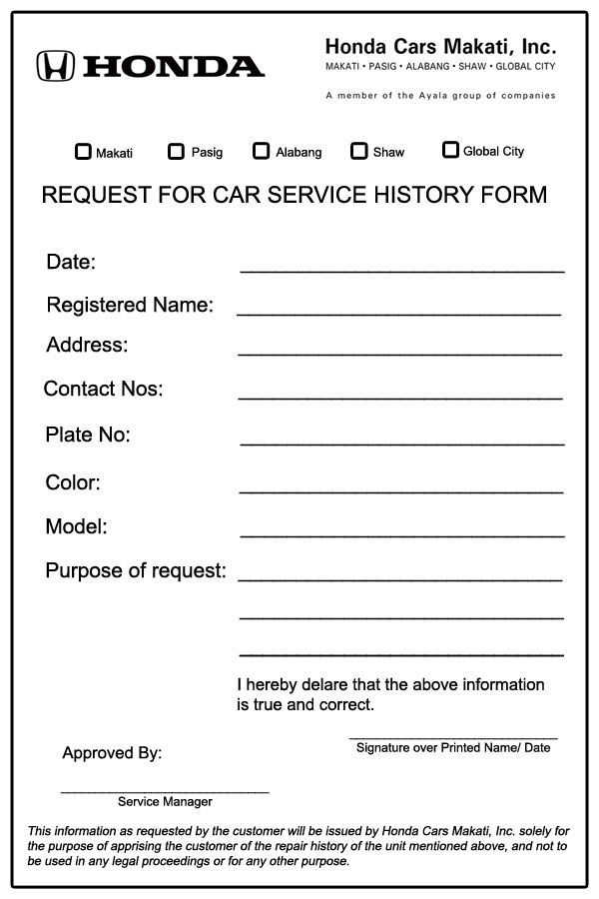](http://www.google.com/url?sa=i&rct=j&q=&esrc=s&source=images&cd=&cad=rja&uact=8&ved=0CAcQjRw&url=http://www.hondamakati.com.ph/Ver3/Scripts/Service_Appointment/&ei=FFFjVY2NFqfjywOP54KgBg&bvm=bv.93990622,d.bGg&psig=AFQjCNHMU6NkJBeJL4ZkOomkTK0ySnsqyA&ust=1432657367448085)Autoservisa pakalpojuma pieteikumi

[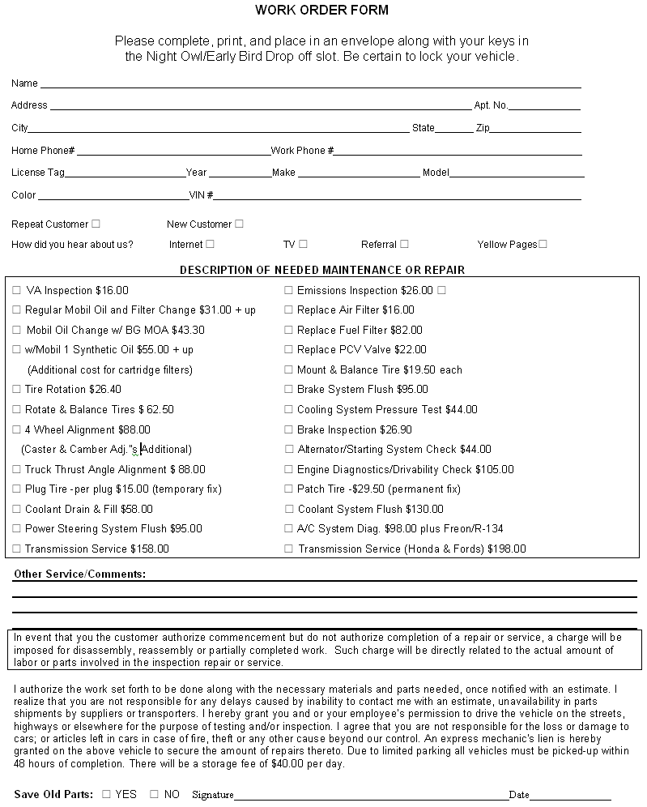](http://www.google.com/url?sa=i&rct=j&q=&esrc=s&source=images&cd=&cad=rja&uact=8&ved=0CAcQjRw&url=http://blog2search.in/tag/automotive-shops&ei=FFFjVY2NFqfjywOP54KgBg&bvm=bv.93990622,d.bGg&psig=AFQjCNHMU6NkJBeJL4ZkOomkTK0ySnsqyA&ust=1432657367448085)

[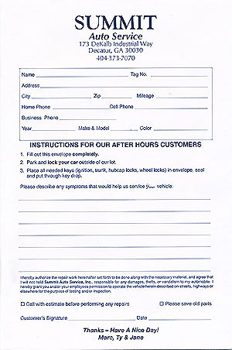](http://www.summitautoservice.com/afterHours.htm)

[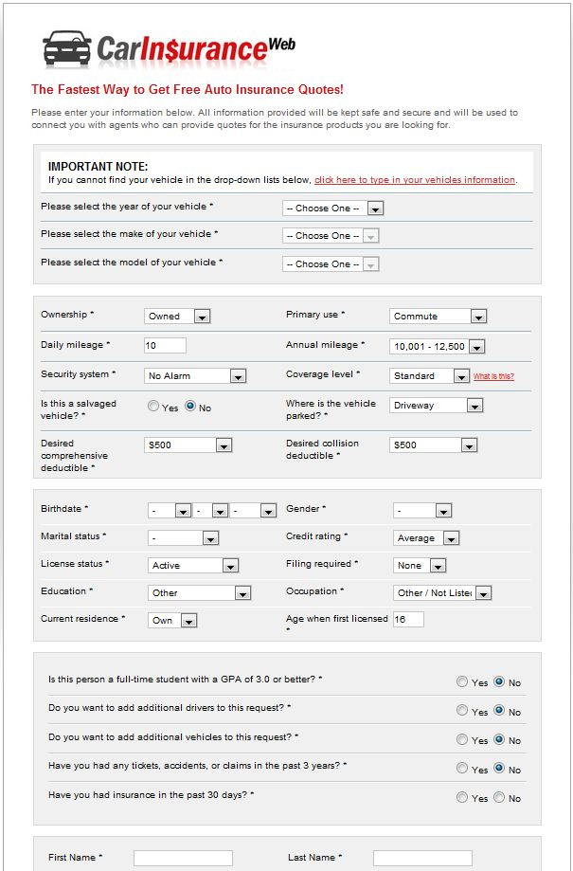](http://www.car-insurance-leads.com/how-our-auto-lead-program-works)

[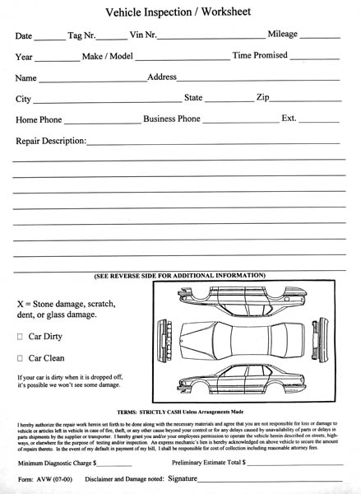](http://www.google.com/url?sa=i&rct=j&q=&esrc=s&source=images&cd=&cad=rja&uact=8&ved=0CAcQjRw&url=http://apkxda.com/honda_multi_point_vehicle_inspection_checklist.html&ei=UlRjVd7VA8KssgHPz4OwBw&bvm=bv.93990622,d.bGg&psig=AFQjCNGy8jwVs1kqB4qDp34zKZRcn7LZQA&ust=1432659271120055)

[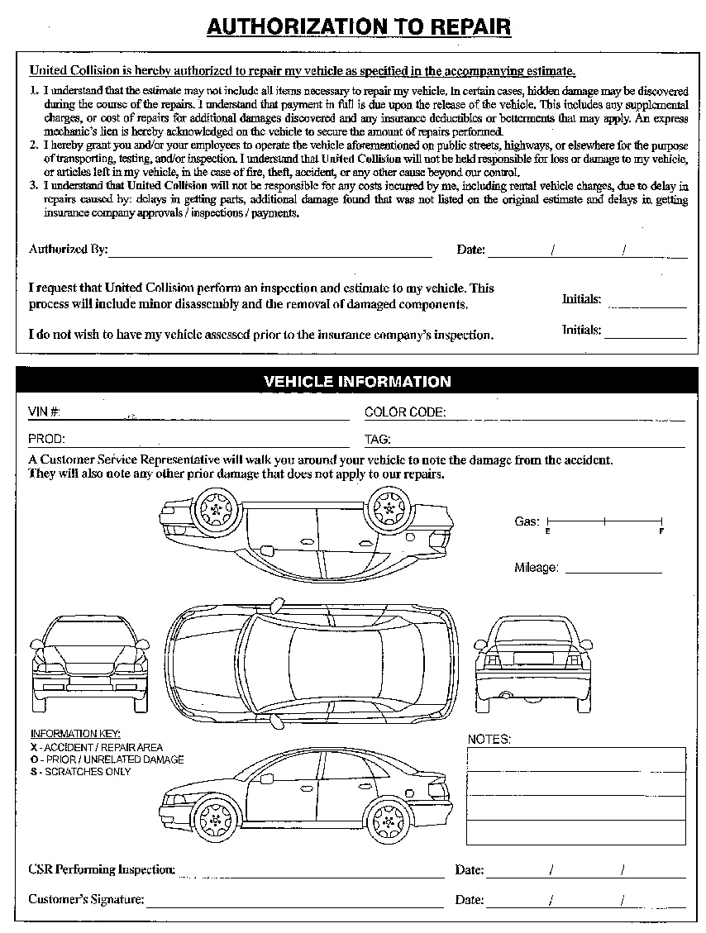](http://www.unitedcollisioncenter.com/check-in-form.aspx)

[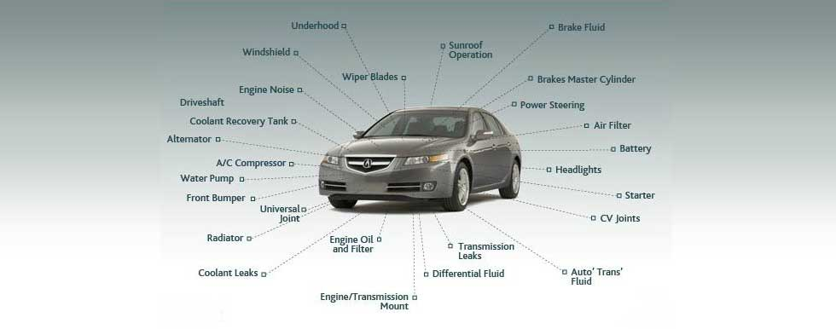](http://www.google.com/url?sa=i&rct=j&q=&esrc=s&source=images&cd=&cad=rja&uact=8&ved=0CAcQjRw&url=http://www.acuraofseattle.com/seattle-acura-certified&ei=VlZjVffBF8qTsAH_6ID4Ag&bvm=bv.93990622,d.bGg&psig=AFQjCNFEhff1Uz46r_iqXD99HM7w7tWJ7Q&ust=1432659752122267)

[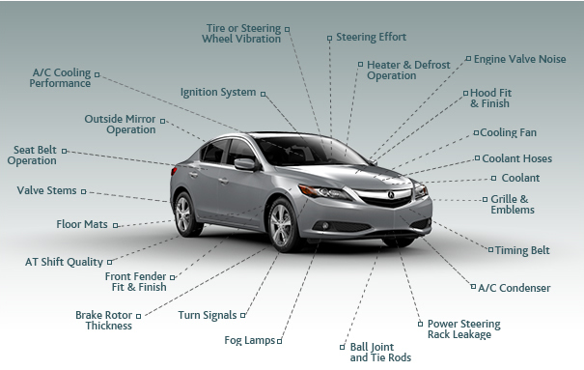](http://www.google.com/url?sa=i&rct=j&q=&esrc=s&source=images&cd=&cad=rja&uact=8&ved=0CAcQjRw&url=http://www.acura.com/Certification.aspx&ei=uFZjVcmyHImOsgHU1oGgCg&bvm=bv.93990622,d.bGg&psig=AFQjCNFEhff1Uz46r_iqXD99HM7w7tWJ7Q&ust=1432659752122267)