Izglītības programma: Autotransports
Kvalifikācija: Autoelektriķis, 3.līmenis
Mācību priekšmets: Profesionālā angļu valoda
Mācību materiāls: autodiagnostikas ierīces
Skolotājs: Dace Cine

Diagnostics Products
GEG Diagnostics have a large range of high quality automotive diagnostic and scanning tools for cars, vans and trucks available, to suit all garages and workshops.
Our diagnostic products range can cover all vehicle manufacturers, with excellent leasing deals available to suit all businesses.

The XTool PS201
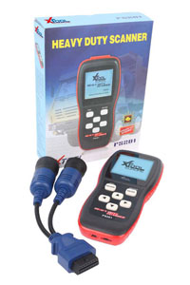
The PS201 heavy duty CAN OBDII code reader has been designed and built to specifically diagnose Truck, Bus and Coach OBDII/ EOBD/ CANBUS compliant vehicles from 1996 onwards. The PS201 also covers Construction, Marine and Agriculture applications. It provides an affordable solution for truck, bus and coach diagnostics. It may be small in size but it is powerful enough to perform the same tasks as premium level workshop scanners while being faster and more user friendly.
It works on all OBD II compliant vehicles manufactured from 1996 onwards and EOBD compliant vehicles manufactured from 2001 onwards. It supports CAN (controller area network) and all other current OBD protocols and can easily determine the cause of the check engine light (MIL) and turn it off as well as clear codes and reset monitors. It retrieves generic (P0, P2, P3, B0, C0, U0), manufacturer specific (P1, P3, and U1) codes, and pending codes and displays DTC definitions.
In addition to all this it displays live vehicle data such as engine speed, air flow meter, accelerator pedal position, engine coolant temperature and updates via the internet.

The Autoboss V30 ELITE
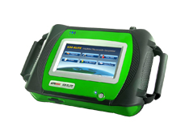
The AUTOBOSS V30 ELITE scanner represents the cutting edge of automotive diagnostic technology, providing dealer quality electronic diagnostics for the independent workshop in one simple and affordable unit.
The V30 ELITE system covers the full range of vehicle models, making it an essential tool for the independent automotive expert. The AUTOBOSS V30 ELITE package will allow your business to expand by providing ready diagnosis of a broad range of systems for all European, US and Asian cars, including Mercedes, BMW, Audi, Vauxhall, Volkswagen, and many more!
All in all, the V30 ELITE coverage spans over 40 manufacturers with up to 148 systems per vehicle.
Best of all, the V30 ELITE’S vehicle coverage continues to grow, with simple internet-ready updates accessible to you at the click of a button. Unlike other tools and diagnostic equipment, the V30 ELITE is an investment that actually increases in value as time goes by.
The AUTOBOSS internet database features newly added models and diagnostic software functions on an almost daily basis - making this rapidly expanding technology an essential investment for the professional auto technician.

Features
- European, US & Asian vehicles with dealer-level power
- Widest vehicle range gives you the best value in a single unit
- More OEM level diagnostics than any other tool in the aftermarket industry
- More than just reading & clearing fault codes - goes far beyond and accesses the complete vehicle, including: drive line, chassis, body, and the networking/communication modules
- Live data and graphing, performs actuations and adaptations
- Key programming, Electronic parking brake, Service light reset and much more
- Easy to use large VGA colour touch screen
- All necessary cables and adapters included
- Built in mini printer
- Simple and direct interface without the "Bells & Whistles;" gets right to the problem- quickly and efficiently
- A4 printing capability
- Onboard help manuals
- Self learning function
- Onboard WiFi for instant software updates
- Constant updates and downloads keep the system the on the cutting edge of industry technology
- Live phone support from REAL technicians

The XTool VAG401
- 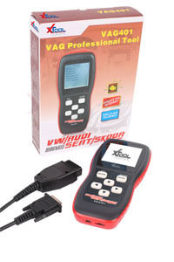
- The VAG401 tool is the perfect solution for diagnosing VW, Audi, Seat and Skoda vehicles. It may be small in size but it is powerful enough to perform the same tasks as premium level workshop scanners whilst being faster and more user friendly.
- It has a natural ergonomic design with large easy operate buttons and a large mono colour screen. It reads and erases Diagnostic Trouble Codes (DTCs) of Engine, ABS, Airbags,Transmission, Radio, Climate Control (A/C), Central Electrics, Steering Wheel, Instruments, Immobiliser, etc. (over 100 Systems covered).
- It also reads and clears generic trouble codes – KWP-1281, KWP-2000 (ISO 14230), TP2.0 CAN and turns off Engine warning light, Airbags, ABS , A/T and other systems on VAG. (only engine system faults on non VAG cars). It has C.A.N Controller Area Network) capability and a super fast One-Click solution for service reset.
- The XTool VAG 401 retrieves vehicle information (VIN), displays I/M Readiness Status, displays DTC definitions on unit screen and has full function support including coding and adaptation. It has full system support and updates via the internet.
- Functions
- The XTool VAG 401 reads and clears diagnostic trouble codes, views live data, offers actuation tests and system basic adjustment adaptation. It also offers coding, I/M readiness and special functions such as oil reset, airbag reset, throttle adaption, mileage reset, EEPROM access and EPB brake pad replacement.

Izziņu avots: iekārtu reklāmu materiāli

