Cauruļvadu un kabeļu loģistika.

Izziņas avots: [www.neogeo.lv](http://www.neogeo.lv); [www.gasprom.com](http://www.gasprom.com), wikipedia

Gāzesvada South Stream kopgarums būs 3600 kilometri, un gada laikā pa to iecerēts piegādāt 63 miljardus kubikmetru gāzes. Plānots, ka pirmās piegādes, kas novadīs Krievijas gāzi caur Bulgāriju uz Rietumeiropu pa cauruļvadu Melnās jūras gultnē, apejot Ukrainas teritoriju, South Stream sāks 2015.gada nogalē.

Kā liecina Gazprom sniegtā informācija, kopējās South Stream izmaksas varētu sasniegt 16,5 miljardus eiro (11,59 miljardus latu) - 10 miljardi eiro būs nepieciešami gāzes vada būvniecībai Melnajā jūrā, bet vēl 6,5 miljardi eiro būs vajadzīgi būvniecības darbiem sauszemē. Krievija piekritusi piešķirt šim projektam 7,5 miljardus eiro ar nosacījumu, ja Gazprom tajā būs 50% daļu.

Ceturtdaļa no Eiropas Savienībā (ES) patērētās gāzes tiek iegūta no Krievijas, un aptuveni 80% no tās tiek transportēti cauri Ukrainai. Ar Krievijas plānoto gāzes vadu konkurē Eiropas iecerētais gāzes vads Nabucco, taču šī projekta realizāciju skārušas jau vairākas problēmas, tostarp potenciālo piegādātāju trūkums, veicinot runas par citām iespējām. Plānots, ka Nabucco tiks būvēts no Turcijas pilsētas Erzurumas līdz Baumgartenai Austrijā, šķērsojot Bulgāriju, Rumāniju un Ungāriju. 4000 kilometru garā gāzes vada aptuvenās izmaksas patlaban tiek lēstas 7,9 miljardu eiro apmērā.

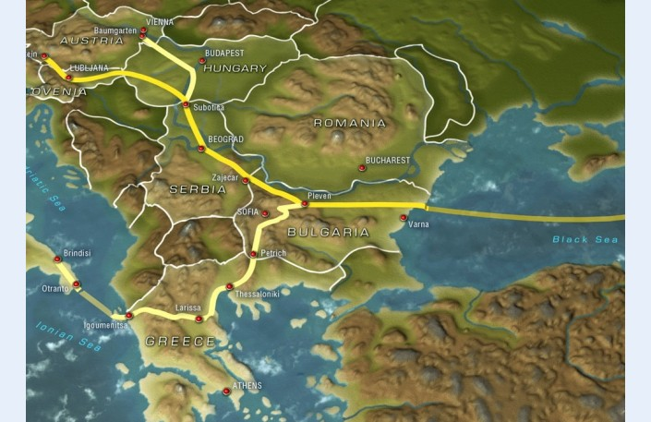



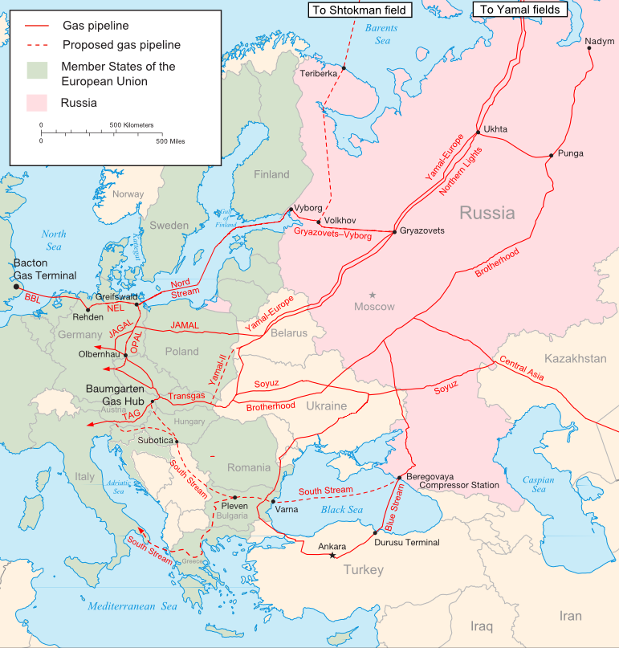

|  |  |  |  |  |  |  |  |  |  |  |  |  |  |  |  |  |  |  |  |  |  |  |  |  |  |  |  |  |  |  |  |  |  |  |  |  |  |  |  |  |  |  |  |  |  |  |
| --- | --- | --- | --- | --- | --- | --- | --- | --- | --- | --- | --- | --- | --- | --- | --- | --- | --- | --- | --- | --- | --- | --- | --- | --- | --- | --- | --- | --- | --- | --- | --- | --- | --- | --- | --- | --- | --- | --- | --- | --- | --- | --- | --- | --- | --- | --- |
| [om pipelines and export capacity](http://www.eegas.com/fsu.htm)  [http://www.eegas.com/images/archive/th_fsu1.png](http://www.eegas.com/fsu.htm)  [Газопроводы Газпрома и экспортные мощности](http://www.eegas.com/fsu_r.htm)  [Gas pipelines of West Siberia](http://www.eegas.com/yamal_westsib.htm)  [http://www.eegas.com/images/th-yamwsib.png](http://www.eegas.com/yamal_westsib.htm)  [Газопроводы Западной Сибири](http://www.eegas.com/yamal_westsib_ru.htm)  [Export flows of Gazprom](http://www.eegas.com/terminal_flows.htm)  [http://www.eegas.com/images/Terminal-1_th.png](http://www.eegas.com/terminal_flows.htm)  [Экспортные потоки](http://www.eegas.com/terminal_flows.htm)  [Spot, Gazprom, Brent](http://www.eegas.com/price_chart.htm)  [http://www.eegas.com/images/Spot-Brent-Gazprom_1.png](http://www.eegas.com/price_chart.htm)  [Цены на нефть и газ](http://www.eegas.com/price_chart.htm)  [End-use price of gas](http://www.eegas.com/US-RUS_end-use_price.htm)  [http://www.eegas.com/images/archive/US-RUS_th.gif](http://www.eegas.com/US-RUS_end-use_price.htm)  [Russia and USA](http://www.eegas.com/US-RUS_end-use_price.htm)  [Daily gas production](http://www.eegas.com/prod_chart.htm)  [http://www.eegas.com/images/archive/prod_th.jpg](http://www.eegas.com/prod_chart.htm)  [Суточная добыча](http://www.eegas.com/prod_chart.htm) |  | ***Selected Maps and Schemes of Gas Pipelines of Russia and the FSU***   |  |  |  |  | | --- | --- | --- | --- | | [Gazprom Pipelines in the FSU](http://www.eegas.com/fsu.htm)  [http://www.eegas.com/images/th-fsu.jpg](http://www.eegas.com/fsu.htm) | [ЕСГ России](http://www.eegas.com/fsu_r.htm)  [http://www.eegas.com/images/th-fsu.jpg](http://www.eegas.com/fsu_r.htm) | [West Siberia](http://www.eegas.com/siberia.htm)  [http://www.eegas.com/images/th-ureng.jpg](http://www.eegas.com/siberia.htm) | [Yamal Fields](http://www.eegas.com/yamal.htm)  [http://www.eegas.com/images/th-yamal.png](http://www.eegas.com/yamal.htm) | | [Ukrainian Pipelines](http://www.eegas.com/ukraine.htm)  [http://www.eegas.com/images/th-ukr.jpg](http://www.eegas.com/ukraine.htm) | [Kazakhstan](http://www.eegas.com/kazakh.htm)  [http://www.eegas.com/images/th-kaz.jpg](http://www.eegas.com/kazakh.htm) | [Export Terminals](http://www.eegas.com/uzhgorod.htm)  [http://www.eegas.com/images/th-uzh.jpg](http://www.eegas.com/uzhgorod.htm) | [Turkmen gas distance](http://www.eegas.com/images/Prikaspiisky_Kaz-China_Trans_e.jpg)  [http://www.eegas.com/images/Th_Turkmen_dist.jpg](http://www.eegas.com/images/Prikaspiisky_Kaz-China_Trans_e.jpg) | | [Pipeline Ruptures](http://www.eegas.com/breaks.htm)  [http://www.eegas.com/images/breakgif1.gif](http://www.eegas.com/breaks.htm) | [Yamal Shelf](http://www.eegas.com/shelf.htm)  [http://www.eegas.com/images/th-shelf.PNG](http://www.eegas.com/shelf.htm) | [Gas Storage Facilities](http://www.eegas.com/storage.htm)  [http://www.eegas.com/images/th-storage.PNG](http://www.eegas.com/storage.htm) | [Pipelines of Belorussia](http://www.eegas.com/belorussia.htm)  [http://www.eegas.com/images/th-belarus.gif](http://www.eegas.com/belorussia.htm) | | [Gas Pipelines of Belarus](http://www.eegas.com/belarus1.htm)  [http://www.eegas.com/images/th-bel1.png](http://www.eegas.com/belarus1.htm) | [Nabucco & Caspian Pipeline](http://www.eegas.com/nabucco.htm)  [http://www.eegas.com/images/archive/th-Nabucco1.jpg](http://www.eegas.com/nabucco.htm) | [Gas Pipelines of Europe & Asia](http://www.eegas.com/europipe.htm)  [http://www.eegas.com/images/archive/th-ESG_Europe.PNG](http://www.eegas.com/europipe.htm) | [Altay Pipeline to China](http://www.eegas.com/altay.htm)  [http://www.eegas.com/images/archive/th-altay.PNG](http://www.eegas.com/altay.htm) | | [Baltic Gas Pipelines](http://www.eegas.com/estonia.htm)  [http://www.eegas.com/images/th-eston.JPG](http://www.eegas.com/estonia.htm) | [Baltic States & Finland](http://www.eegas.com/baltmap.htm)  [http://www.eegas.com/images/th_LatGaz.JPG](http://www.eegas.com/baltmap.htm) | [Газопроводы Ямала](http://www.eegas.com/yamal_westsib_ru.htm)  [http://www.eegas.com/images/th_Yam_WS.png](http://www.eegas.com/yamal_westsib_ru.htm) | [Gas pipelines of Yamal](http://www.eegas.com/yamal_westsib.htm)  [http://www.eegas.com/images/th_Yam_WS.png](http://www.eegas.com/yamal_westsib.htm) | | [South Stream & Ukrainian Shelf](http://www.eegas.com/southstream.htm)  [http://www.eegas.com/images/th_S_Stream_shelf.PNG](http://www.eegas.com/southstream.htm) | [South Stream & Nabucco](http://www.eegas.com/southstream1.htm)  [http://www.eegas.com/images/archive/th-Nabucco2.JPG](http://www.eegas.com/southstream1.htm) | [Украинский транзит-янв-2009](http://www.eegas.com/ukr_010609r.htm)  [http://www.eegas.com/images/ZminaRezimGTS_31_12_2008_th.jpg](http://www.eegas.com/ukr_010609r.htm) | [Ukrainian transit, Jan-2009](http://www.eegas.com/ukr_010609e.htm)  [http://www.eegas.com/images/ZminaRezimGTS_31_12_2008_th.jpg](http://www.eegas.com/ukr_010609e.htm) | | [Czech transit in 2018](http://www.eegas.com/czech-2018.htm)  [http://www.eegas.com/images/czech1.PNG](http://www.eegas.com/czech-2018.htm) | [Scheme of Ukrainian pipelines](http://www.eegas.com/ukr_090115e.htm)  [http://www.eegas.com/images/Ukr_techno3_map.png](http://www.eegas.com/ukr_090115e.htm) | [Storage facilities of Gazprom](http://www.eegas.com/images/Storage_facilities-Gazprom-website_map-en.png)  [http://www.eegas.com/images/th-storagemap.png](http://www.eegas.com/images/Storage_facilities-Gazprom-website_map-en.png) | [ПХГ Газпрома](http://www.eegas.com/images/Storage_facilities-Gazprom-website_map-ru.png)  [http://www.eegas.com/images/th-storagemap.png](http://www.eegas.com/images/Storage_facilities-Gazprom-website_map-ru.png) | | [Южный поток](http://www.eegas.com/southstream2r.htm) (новая)  [http://www.eegas.com/images/archive/th-Nabucco2.JPG](http://www.eegas.com/southstream2r.htm) | [South Stream (new)](http://www.eegas.com/southstream2e.htm)  [http://www.eegas.com/images/archive/th-Nabucco2.JPG](http://www.eegas.com/southstream2e.htm) | [Yamal - South Stream](http://www.eegas.com/images/SouthStream-Baumgarten_en.jpg)  [http://www.eegas.com/images/SouthStream-Baumgarten_en_th.jpg](http://www.eegas.com/images/SouthStream-Baumgarten_en.jpg) | [South Stream shortcut](http://www.eegas.com/SouthStream_short-2011-04e.htm)  [http://www.eegas.com/images/SouthStream-Baumgarten_en_th.jpg](http://www.eegas.com/SouthStream_short-2011-04e.htm) | | [Black Sea shelf](http://www.eegas.com/images/South_Stream_shelf_en.png)  [http://www.eegas.com/images/South_Stream_shelf_th.png](http://www.eegas.com/images/South_Stream_shelf_en.png) | [Шельф Чёрного моря](http://www.eegas.com/images/South_Stream_shelf_ru.png)  [http://www.eegas.com/images/South_Stream_shelf_th.png](http://www.eegas.com/images/South_Stream_shelf_ru.png) | [South Stream & South. Corridor](http://www.eegas.com/images/archive/South_Stream-Southern_Corridor-2011-12.jpg)  [http://www.eegas.com/images/archive/South_Stream-Southern_Corridor-2011-12_th.jpg](http://www.eegas.com/images/archive/South_Stream-Southern_Corridor-2011-12.jpg) | [Pincer Movement](http://www.eegas.com/images/archive/Pincer_movement_2012-05.jpg)  [http://www.eegas.com/images/archive/Pincer_movement_2012-05_th.jpg](http://www.eegas.com/images/archive/Pincer_movement_2012-05.jpg) | | [Yamal-Europe-2](http://www.eegas.com/images/Yamal-Europe-2.jpg)  [http://www.eegas.com/images/Yamal-Europe-2_th.jpg](http://www.eegas.com/images/Yamal-Europe-2.jpg) | [Russia & Ukraine](http://www.eegas.com/ukr-rus-2014-02.htm)  [http://www.eegas.com/images/archive/South_Stream-Southern_Corridor-2011-12_th.jpg](http://www.eegas.com/ukr-rus-2014-02.htm) | [Ukrainian gas pipelines](http://www.eegas.com/ukraine_2014-03.htm)  [http://www.eegas.com/images/archive/2014-03-01_Ukraine_gas_th.png](http://www.eegas.com/ukraine_2014-03.htm) | [Газопроводы Украины](http://www.eegas.com/ukraine_2014-03.htm)  [http://www.eegas.com/images/archive/2014-03-01_Ukraine_gas_th.png](http://www.eegas.com/ukraine_2014-03.htm) | | [Yamal-Baumgarten](http://www.eegas.com/yamal-baumgarten-2014-05.htm)  [http://www.eegas.com/images/Baumgarten_short-2014-05_th.jpg](http://www.eegas.com/yamal-baumgarten-2014-05.htm) | [Turkish Stream](http://www.eegas.com/turkish_stream_2015-01.htm)  [http://www.eegas.com/images/2015-01-27_Turkish_Stream_th.jpg](http://www.eegas.com/turkish_stream_2015-01.htm) |  |  | |

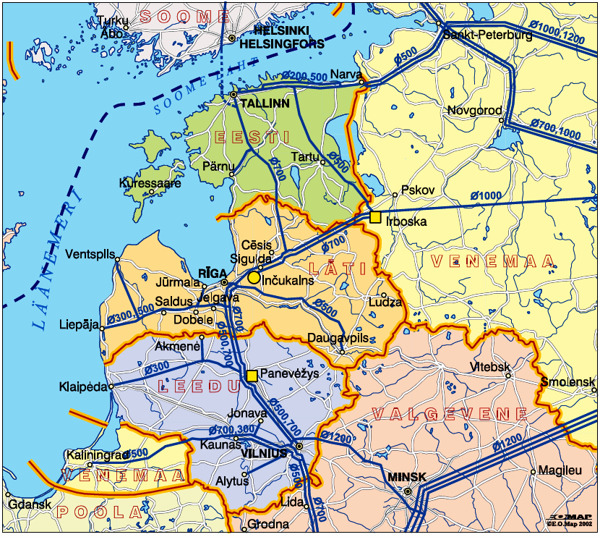

[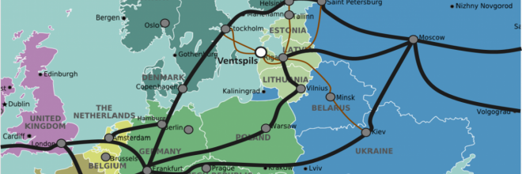](http://www.portofventspils.lv/sites/default/files/styles/660x510/public/attels_karte_1_0.png?itok=92eEAZwy)

Latvijā un Ventspilī ir izbūvēti optiskie interneta tīkli, kuru vidējais interneta ātrums jau gadiem ierindo Latviju **pasaules valstu TOP 7**.

Ventspils priekšrocība ir vairāki neatkarīgi lieljaudas **optisko kabeļu** savienojumi ar **starptautiskajām datu maģistrālēm** — 2 zemjūras un 5 (no 2015. gada — sešas) virszemes optikas līnijas nodrošina datu pārraidi gan Skandināvijas un ES, gan arī Krievijas un NVS valstu virzienā.

Ventspils ir globālā optiskā tīkla zemjūras savienojuma posms ar Zviedriju. No Ventspils uz Stokholmu stiepjas 2 neatkarīgas **zemjūras starptautiskā optiskā kabeļa līnijas**, ko apkalpo kabeļu līniju operatori *Lattelecom* un *Baltcom Fiber*. Uzņēmumiem ir iespēja izmantot abu operatoru pakalpojumu kombināciju:

* *Baltcom Fiber* pieder Baltijas jūrā jaunākais 68 šķiedru zemjūras optiskais kabelis Ventspils–Gotlande–Stokholma (ražotājs — *Ericsson*) ar katras šķiedras pārraides caurlaidību 10–40 Gbps un starptautiskajā IP datu pārraidē garantētu pakalpojuma pieejamību (99,7 % apjomā).
* Nacionālajai kompānijai *Lattelecom* papildus 10 Gbps zemjūras optiskajam savienojumam ir plašs, ar ES kaimiņvalstīm savienots virszemes sakaru tīkls.

**5 virszemes līnijas** (*Lattelecom*, *Latvenergo*(2 līnijas), *Latvijas Dzelzceļš* un *LVRTC*) no Ventspils caur Rīgu nodrošina datu apmaiņu vairākos starptautiskajos tīklos:

* ziemeļu virzienā — caur Igauniju uz Somiju un Zviedriju, un tālāk uz Eiropas maģistrālajiem datu apmaiņas mezgliem Vācijā;
* dienvidu virzienā — caur Lietuvu uz Centrāleiropas valstīm un, izveidojot cilpu, uz Vāciju un Eiropas maģistrālajiem datu apmaiņas mezgliem;
* austrumu virzienā — caur Maskavu un Sanktpēterburgu, veidojot cilpu ar Somiju un Zviedriju.