Izglītības programma: telemehānika un loģistika
Loģistikas speciālists
Mācību priekšmets: transporta ģeogrāfija
Skolotājs: Dace Cine

Ievads transporta ģeogrāfijā

Izziņas Resursi: Source: adapted from Metrobits.org, World Metro Database.
Source: Ashar and Rodrigue, 2012
Source: data from Containerization International.

THE GEOGRAPHY OF TRANSPORT SYSTEMS

- Cartography is the most obvious example of a geographic technique. Indeed, various types of maps are used in the analysis of transport systems, including land use maps, depictions of transport infrastructure, isoline maps of transportation costs, or schematics of transportation activity patterns.
- Geographic information systems (GIS), which are an outgrowth of digital cartography, provide a set of tools for storing, retrieving, analyzing and displaying spatial data from the real world. GIS technology has been applied to some large-scale transportation planning and engineering applications. More often, however, GIS are applied in a prescriptive way to small-scale problems, for example to plot optimal routes for buses, delivery trucks, or emergency vehicles.
- There are also various statistics that have been developed or modified by geographers to describe urban-economic systems. Examples include the Gini coefficient and indexes of concentration and specialization.

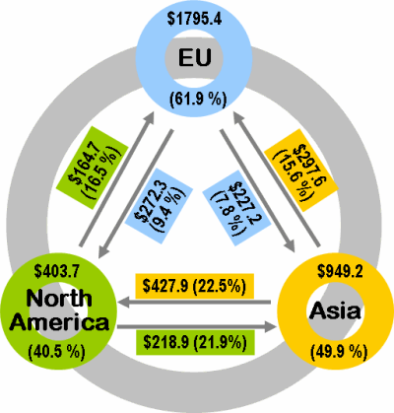
In billions of dollars and in % of all exports.
Source: WTO International Trade of Merchandises, 2003 The recent decades have seen important changes in international trading flows. The bulk of international trade occurs within economic blocs, especially within the European Union and NAFTA. Other significant flows are between Asia / Pacific and North America (especially the United States), between Europe and North America and between Europe and Asia / Pacific. For several reasons, such as geographical proximity (Eastern Europe), energy (Middle East) and colonial legacy (Africa), the European Union has significant trading linkages with the "rest of the world". North America, also maintains important trade linkages with Latin America. Another important characteristic of the contemporary commercial setting concerns imbalances in trade flows. For instance, it is clear on the above figure that the Asia / Pacific region exports more than it imports and that North America imports more than it exports. Three major poles account for the majority of the global trade, about 80% of all exports. Most of this trade is however regional in scale, particularly within the European Union (EU) where close to 62% of all exports are taking place between its members. The vastness of Asia as a statistical unit partially hides a higher level of export dependency than the 50% figure. Trade imbalances, notably between Asia and North America, are particularly prevalent.

Transportation and Commercial Geography Authors: Dr. Jean-Paul Rodrigue and Dr. Claude Comtois 1. Trade and Commercial Geography Trade, the exchange of goods and services over long distances, and commercial activities, the exchange of goods and services at specific markets, are core components of the economy. Trade and commerce have evolved in space and in time, from low volume and limited extent prior to the industrial revolution, to the extensive flows and transactions that characterize the contemporary global economy. Historically, wealth was dominantly related to agricultural output implying that the largest economies were those with the largest populations, but these populations were mainly rural and with low income. As such, trade and commerce were marginal activities. The industrial revolution irremediably changed trade and commerce with mechanization and its multiplying effects on production and consumption. Yet, in spite of substantial growth in production capabilities, economic systems remain based on trade and transactions since specialization and efficiency require interdependency. People trade their labor for a wage, having to commute in the process, while corporations trade their output for capital, having to access markets. Trade is the transmission of a possession in return for a counterpart, generally money, which is often defined as a medium of exchange. This exchange involves a transaction and its associated flows of capital, information, commodities, parts, or finished products. All these activities define commercial geography.
Commercial geography investigates the spatial characteristics of trade and transactions in terms of their nature, causes and consequences. It leans on the analysis of transactions, from a simple commercial transaction involving an individual purchasing a product at a store, to the complex network of transactions maintained between a multinational corporation and its suppliers. The scale and scope of commercial geography varies significantly.
Trade, in terms of its origins and destinations, has a spatial logic. It reflects the economic, social and industrial structure of the concerned markets, but also implies other factors such as transport costs, distance, trade agreements, exchange rates and the reciprocal economic advantages proponents get from trade. For trade to occur several fundamental conditions must be met:
- Availability. Commodities, from coal to computer chips, must be available for trade and there must be a demand for these commodities. In other terms, a surplus must exist at one location and a demand in another, which implies a level a reciprocity. A surplus can often be a simple matter of investment in production capabilities, such as building an assembly plant, or can be constrained by complex geological and environmental factors like the availability of resources such as fossil fuels, minerals and agricultural products.
- Transferability. Transport infrastructures, in allowing goods to be moved from their origins to their destinations, support the transferability of goods. There are three major impediments to transferability, namely regulatory barriers (tariffs, custom inspections, quotas), geographical barriers (time, distance) and transportation barriers (the simple capacity to move the outcome of a transaction). Distance often plays an important role in trade, as does the capacity of infrastructures to route and to transship goods.
- Transactional capacity. It must be legally possible to make a transaction. This implies the recognition of a currency for trading and legislations that define the environment in which commercial transactions are taking place, such as taxation and litigation. In the context of a global economy, the transactional environment is very complex but is important in facilitating trade at the regional, national and international levels. The fundamental elements of a commercial transaction involving the transportation of a good are the letter of credit and the bill of lading. The transport terms have been regulated since 1936 by international commercial terms, which defines the respective responsibilities of the actors involved. Such terms are regularly updated and revised to reflect commercial and regulatory changes in global markets.
Once these conditions are met, trade is possible and the outcome of a transaction results in a flow (or interaction). Three particular issues relate to the concept of flow:
- Value. Flows have a negotiated value and are settled in a common currency. The American dollar, which has become the main global currency, is used to settle and/or measure many international transactions. Further, nations must maintain reserves of foreign currencies to settle their transactions. The relationship between the inbound and outbound flows of capital is known as the balance of payments. Although nations try to maintain a stable balance of payments, this is rarely the case; flows are commonly imbalanced.
- Volume. Flows have a physical characteristic, mainly involving a mass. The weight of flows is a significant variable when trade involves raw materials such as petroleum or minerals. However, in the case of consumption goods, weight has little significance relatively to the value of the commodities being traded. With containerization, a new unit of volume has been introduced; the TEU (Twenty-Foot Equivalent Unit), which can be used to assess trade flows.
- Scale. Flows have a range which varies significantly based on the nature of a transaction. While retailing transactions tend to occur at a local scale, transactions related to the operations of a multinational corporation are global in scale.
Cities are the world's major commercial centers, but the commercial importance of a city is relative to a number of factors such as financial flows, the ease of doing business and transport infrastructure. Traditionally, commercial activities tended to develop where there was a physical break along transport chains. Cargo needed to be transferred from one mode to another and a new actor took over its ownership or its custody. The physical break imposed transactions, an important reason why most the world's most important financial centers tend to be port cities or major load break centers in the hinterland. 2. Trends in Commercial Geography The contemporary commercial setting is marked by increasing free trade and profound technological, industrial and geopolitical changes. The liberalization of trade, as confirmed by the implementation of the World Trade Organization, has given a strong impetus in the growth rate of world trade and industrial production. This has led to competitive pressures and shifting competitive advantages between regions. Even if in a true free trade environment, regulatory agencies would not be required, in spite of attempts at deregulation, transactions and trade are prone to disputes, litigations and perceived imbalances concerning who benefits the most. Although these issues mainly apply to international trade, there are also situations where trade is constrained between jurisdictions (provinces, states) of a nation. After decades of globalization and ongoing growth, much of the trade remains dominantly regional. An overview of world trade flows indicate that trade within regions is more significant than trade between regions, but long distance trade has steadily been growing. This has been associated with an increasing share of East Asia, especially China, in world trade both in terms of exports and imports. Flows of merchandises have also been accompanied by a substantial growth in foreign direct investments. A remarkable reallocation of production capacities has taken place through outsourcing and offshoring following changes in comparative advantages around the world. This trend goes in tandem with mergers and acquisitions of enterprises that are increasingly global in scope. The analysis of international trade thus reveals the need to adopt different strategies to adapt to this new trading environment. As production is being relocated, there is a continuous shift in the structure of exports and imports among nations. The decline of manufacturing in its share of the global GDP is illustrative of the growing complexities that added-value brings to the function of production. It masks a manufacturing sector that is embedded with service activities, such as logistics, and which is increasingly dependent on the generation of added value. Major changes have occurred in the organization of production. There is a noticeable increase in the division of labor concerning the design, planning and assembly in the manufacturing process of the global economy. Interlocking partnerships in the structure of manufacturing have increased the trade of parts and the supply of production equipment around the world. One third of all trade takes place among parent companies and their foreign affiliates. A part of this dynamism resides in the adoption of standards, a process which began in the late 19th century to promote mass production. It permitted the rapid development of many sectors of activity, including railways (gauge), electricity (wattage), the automobile (safety) and the telecommunication industry more recently (communication protocols and electronic data formats). In the realm of globalization of economic activities, the International Standards Organization developed the ISO norms that serve as comparison between various enterprises around the world. These norms are applicable to the manufacturing and services industries and are a necessary tool for growth. There are also indications that the trends that have supported globalization may be receding. The growth of the service sector, particularly their share of the GDP, involves economic activities that are more difficult to trade. Due to rising standards of living, countries are consuming a growing share of their manufacturing output, although this is not taking place uniformly. As a result, the commercial geography is influenced by the market size, the consumption level of an economy (often measured in GDP per capita), but also by the growth potential of different regions of the world. National GDP figures however do not reveal well regional distributions, particularly the prominence of a few large metropolitan areas. At the global level, the bulk of the consumption remains concentrated in a limited number of countries with the G7 countries alone accounting for two third of the global Gross Domestic Product. Economic growth taking place in East and Southeast Asia has been one of the most significant force shaping changes in the contemporary commercial environment. The commodification of the economy has led to significant growth in retail and wholesale and the associated movements of freight. As wages increases across the world, wage differences and their derived comparative are less significant, implying that cheap labor becomes less relevant for competitiveness. While technical advances have benefited transportation, they are also conferring a growing level of automation to production. This implies that locational decision for production will tend to be more market servicing based than factors of production based. 3. Commercialization of the Transport Industry The liberalization of trade was accompanied by a growth of transportation since transactions involves movements of freight, capital, people and information. Developments in the transport sector are matched by global and regional interdependence and competition. Transportation, like commodities, goods and services, is traded, sometimes openly and subject to full market forces, but more often subject to a form of public control (regulation) or ownership. The core component of a transport-related transaction involves its costs that either have to be negotiated between the provider of the service and the user or are subject to some arbitrary decree (price setting such as public transit). Since transportation can be perceived as a service, its commercialization (how it is brought to the market) is an important dimension of its dynamics. Transport service providers tend to be private entities, particularly in the global freight sector. Local passenger transportation providers (transit) tend to be publicly owned. While transport companies have no specific location as modes are allocated to fulfill demand, transportation assets have a deep spatial and locational imprint. One important component of the commercialization of transportation concerns investments in infrastructure, modes and terminals, as well as marketing and financing. Financial activities have seen a concentration among major global financial centers. Investments are performed either to expand the geographical extent and/or the capacity of a transport system or to maintain its operating conditions. The public and private sectors have contributed to the funding of transport investments depending on economic, social and strategic interests. For obvious reasons, the private sector seeks transport investments that promise economic returns while the public sector often invests for social and strategic reasons. In many cases private transport providers have difficulties to act independently in formulating and implementing their transport investments. Various levels of government are often lobbied by transport firms for financial and/or regulatory assistance in projects that are presented as of public interest and benefit. The consolidation of regional markets and the resulting increase in transborder traffic has led transport firms to seek global alliances and greater market liberalization in the transport and communication sector as a mean to attract investments and to improve their productivity. Deregulation and divestiture policy in the transport industry has led governments to withdraw from the management, operations and ownership of national carriers, ports and airports. This has given rise to a major reorganization of the international and national transport sectors with the emergence of transnational transport corporations that are governing the global flow of air, maritime and land trade and the management of airports, ports and railyards. 4. Logistics and Supply Chains The development of logistics and the setting of global supply chains are substantially impacting commercial geography. Freight has commonly been managed by private interests, particularly in the maritime shipping segment. Similarly, the logistics industry is also prone to private commercial interests that owns modes, terminals, distribution facilities and provide management services. The ownership and operations of supply chains is intensive in transactions, flows and information exchange. Logistics is after all the spatial and temporal management of freight flows and with globalization these flows are extensive and complex. As a commercial activity logistics involves a whole range of tasks, from the labor intensive (loading, packaging, unloading) to information management intensive (order processing, booking, routing). Still, the context in which logistics services are offered and managed has changed. Freight transport services are increasingly being outsourced as many companies have acknowledged that transportation and warehousing are not part of their core business. Companies are reducing the number of transportation suppliers to reduce costs and improve services. The development of the logistics industry has enabled many transport companies to take control of larger segments of the supply chain. With an increasing level of functional integration many intermediate steps in the transport chain have been removed. Mergers and acquisitions have permitted the emergence of large logistics operators that control many segments of the supply chain. They are often labeled as third party logistics providers since they almost exclusively take care in the management and operation of logistics on behalf of their customers. Technology has also played a particular role in this process namely in terms of information technology (control of the process) and intermodal integration (control of the flows). Freight distribution promotes regional competitiveness and their integration in global supply chains and thus change the commercial geography of a region. Logistical capabilities are often equated with competitiveness over segments of the supply chain, ranging from resource extraction, manufacturing and retailing. Both public and private interests are now considering various infrastructure and activities related to logistics and supply chain management as high priority projects for national investment and economic development. This often takes the form of logistics zones linked to intermodal terminal facilities, such as ports, rail yards and barge terminals. Logistics is also linked with changes brought be ecommerce. For instance, the growth of online purchases is liked with a decline of the retail commercial footprint, but with the increase of warehousing and distribution.

8. THE GEOGRAPHY OF TRANSPORT SYSTEMS

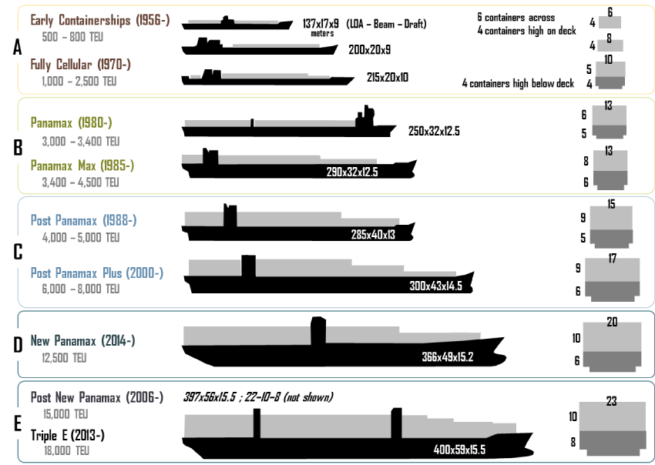
Source: Ashar and Rodrigue, 2012. All dimensions are in meters. LOA: Length overall. Evolution of Containerships Since the beginning of containerization in the mid 1950s, containerships undertook six general waves of changes, each representing a new generation of containership:
- A) Early containerships. The first generation of containerships was composed of modified bulk vessels or tankers that could transport up 1,000 TEUs. The first containership, the "Ideal-X" was a converted World War II T2 tanker. The container was at the beginning of the 1960s an untested transport technology and reconverting existing ships proved out to be of lower cots and less prone to risks. These ships were carrying onboard cranes since most port terminals were not equipped to handle containers. These ships were also relatively slow, with speeds of about 18 to 20 knots and could only carry containers on the converted decks and not in their bellyhold. Once the container began to be massively adopted at the beginning of the 1970s, the construction of the first fully cellular containerships (FCC; second generation) entirely dedicated for handling containers started. All containerships are composed of cells lodging containers in stacks of different height depending on the ship capacity. Cellular containership also offer the advantage of using the whole ship to stack containers, including below deck. Cranes were removed from the ship design so that more containers could be carried (cranes remain today on some specialized containerships). The ability of ports to handle cellular containerships ceased to be a major concern with the setting of specialized container terminals around the world. Cellular containerships were also much faster with speeds of 20-24 knots, whichwould become the speed of reference in containerized shipping.
- B) Panamax. During the 1980s economies of scale rapidly pushed for the construction of larger containerships; the larger the number of containers being carried the lower the costs per TEU. The process became a virtuous circle compounding larger volumes and lower costs, which significantly helped the diffusion of the container. The size limit of the Panama Canal, which came to be known as the panamax standard, was achieved in 1985 with a capacity of about 4,000 TEUs. Once this limit was achieved, a decade passed before a new generation of larger containerships was designed. At the same time panamax container ship designs were evolving to take maximum advantage of the canal's limitation in beam (Panamax Max). The original dimensions of the Panama Canal, built by the US Army Corps of Engineers, are similar to the dimensions of the US Inland Waterways locks, resulting in a narrow and long ship design.
- C) Post Panamax. Going beyond panamax was perceived as a risk in terms of the configuration of shipping networks, additional handling infrastructure as well as draft limitations at ports. The APL C10 containership class, with a capacity of 4,500 TEUs, was introduced in 1988 and was the first containership class to exceeded the 32.2 m width limit of the Panama Canal. By 1996, full fledged Post Panamax containerships were introduced while capacities reached 6,600 TEUs. A ship above the panamax size requires a substantial amount of cargo to be used profitably along a service loop and by the late 1990s the rapid growth of global trade made such a ship class a marketable proposition. Once the panamax threshold was breached, ship size quickly increased with capacities reaching 8,000 TEUs (Post Panamax Plus; "Sovereign Class"). Post Panamax Containerships require deep water ports (at least 43 feet of draft) and highly efficient, but costly, portainers. This is placing pressures on ports to dredge to accommodate these draft constraints.
- D) New Panamax (NPX). Refers to ships designed to fit exactly in the locks of the expanded Panama Canal, expected to open in 2015. These ships will have a capacity of about 12,500 TEU. Like its Panamax counterparts, New Panamax ships will define a specific ship class able to effectively service the Americas and the Caribbean, either from Europe or from Asia.
- E) Post New Panamax. By 2006, a new generation of containerships came online when Maersk shipping line introduced a ship class having a capacity in the range of 11,000 to 14,500 TEUs; the Emma Maersk, (E Class). They are dubbed "Post New Panamax" since they are bigger than the specifications of the expanded Panama Canal and can handle up to about 18,000 TEUs (Triple E Class). It remains to be seen which routes and ports these ships would service, but they are limited mostly to routes between Asia and Europe. There are larger ship designs on the drawing boards, such as the "Malacca Max" class that could carry about 27,000-30,000 TEU, but they are not expected to be constructed within a decade.
Containership speeds have peaked to an average of 20 to 25 knots and it is unlikely that speeds will increase due to energy consumption; many shipping lines are opting for slow steaming to cope with higher bunker fuel prices and overcapacity. The deployment of a class of fast containerships has remained on the drawing boards because the speed advantages they would confer would not compensate for the much higher shipping costs. Supply chains have simply been synchronized with container shipping speeds. Each subsequent generation of containership is facing a shrinking number of harbors able to handle them and placing pressures on port infrastructure and equipment. Maritime shipping companies are incited to use the largest containerships possible on their shipping routes, since they benefit from economies of scale. However, ports and inland transportation systems have to provide substantial capital investment if they expect to accommodate larger containerships. There are thus operational limitations to deploy ships bigger than 8,000 TEU in terms of ports of call and the required infrastructure to provide an acceptable loading and unloading throughput. Also, large containership deployments require a substantial amount of cargo to be commercially feasible. Containerships in the range of 5,500 to 6,500 TEU appear to be the most flexible in terms of the ports they can access and they market they can service since using larger ships require fewer port calls.

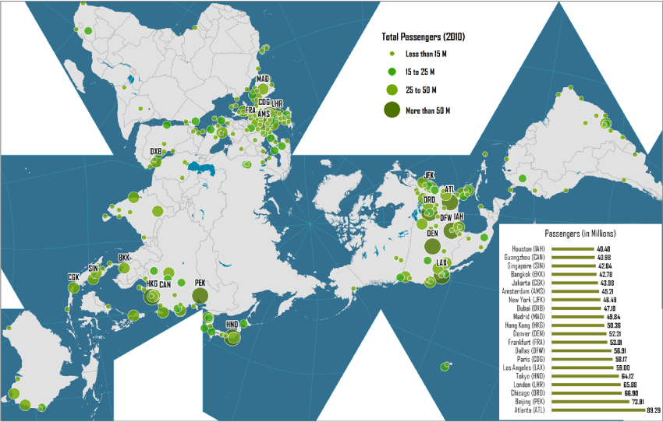
Largest Passenger airports in the world
Source: Airports Council International. Note: airports having a traffic above 4 million passengers (N=268).
(Detailed PDF Map) Passenger Traffic at the World's Largest Airports, 2010 Passenger air travel is linked with the level of economic development and the structure of the regional urban system. There are three major concentrations of airports around which the world's air traffic is articulated: North America, Western Europe and East Asia. The key airports of these platforms, or rather the main airport cities since they count more than one airport, are New York, London and Tokyo. They correspond to the world's most prominent cities and the most important financial centers. Yet, this supremacy is being challenged by new hubs of activity such as Beijing and Dubai. There is thus a direct relationship between the level of air passenger traffic and the primacy of a city in the world urban system. In some cases, the level of passenger activity is related to a pronounced touristic or resort function of an area (e.g. Las Vegas, Orlando, Cancun, Venice, Palma de Mallorca). Large airport terminals are also seeing a substantial concentration of related activities such as distribution centers, just-in-time manufacturers, office parks, hotels, restaurants, and convention centers. Airport traffic figures must be considered with caution as depending on a trip sequence a passenger can be counted several times. For instance, a passenger flying a roundtrip between New York and Copenhagen by transiting through Amsterdam would count for a total of 8 passenger movements for the respective airports; 2 for New York and Copenhagen (arriving and departing) and 4 for Amsterdam (arriving and departing for both inbound and outbound trips).

8. THE GEOGRAPHY OF TRANSPORT SYSTEMS

Largest container ports in the world

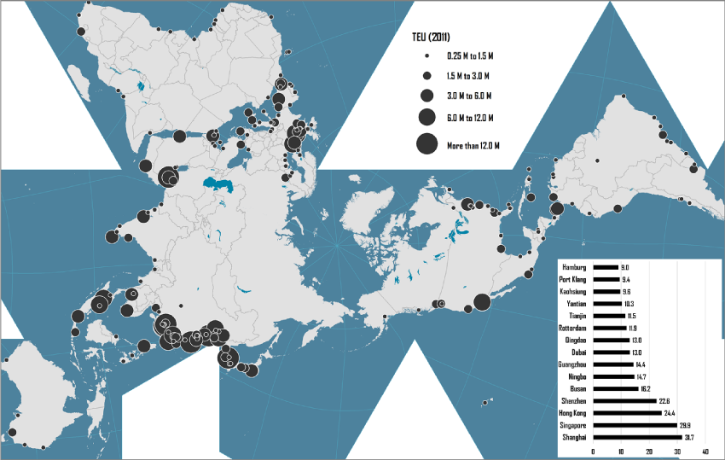
Source: data from Containerization International.
Detailed PDF Map World's Major Container Ports, 2011 Container ports are reflective of the world's commercial geography particularly since they dominantly handle finished and intermediate goods. Prior to the 1990s, the world's most important ports were North American (e.g. New York) and Western European (e.g. Rotterdam). Containerization completely changed the world's commercial geography with the emergence of port locations reflecting changes in the global geography of production and consumption. This geography indicates a high level of traffic concentration around large port facilities, notably Pacific Asian ports along to Tokyo - Singapore corridor. As export oriented economic development strategies took shape, containers handled in Pacific Asian ports, notably Chinese ports, surged. The comparative size of ports requires caution as several ports can be considered more statistical agglomerations than functional entities. For instance, the port of Shenzhen in the Pearl River Delta is composed of several large port facilities (e.g. Yantian, Chiwan, Shekou) that act as distinct entities within their operations and are even servicing different hinterlands. The same observation applies to Guangzhou and Shanghai that are multiport (terminal) entities. The world container port system is characterized by a high level of traffic concentration with the 20 largest container ports handling more than 49% of global traffic in 2011. There is also an emerging geography of container ports where there is a specialization between container ports acting as gateways and container ports acting as intermediate hubs. Gateway ports command the access of large manufacturing or market regions. Hong Kong, Los Angeles and Rotterdam are notable examples of ports that command access to a vast hinterland. Intermediate hub ports (or offshore hubs) act as intermediary locations where containers are transshipped between different segments of the global maritime transport system in a manner similar to hubs in air transportation. Singapore and Dubai are among the most prominent transshipment hubs, each servicing a specific transshipment market. The recent changes in net containerized traffic are reflective of the shifting commercial dynamic in the global economy. Recently, North American ports have experienced limited changes, in part due to peaking consumption levels as well as a recession (2008-10). The same applies to Japanese ports that were experiencing significant growth in the 1970s and 1980s, which was then supplemented by Korean an Taiwanese ports in the 1990s. The most significant growth dynamic is being observed along the Chinese coast where during that period the export-oriented process was in full gear. Ports of the European northern range, mostly Antwerp and Rotterdam, have grown in part due to an extensive hinterland accessibility deep inside Europe. There is also a "transshipment belt" ranging from the Strait of Malacca to the Strait of Gibraltar that has experienced notable traffic growth. It particularly concerns Singapore, Dubai, the outlet of the Suez Canal (e.g. Port Said) and the outlet of the Strait of Gibraltar (Tangier Med, Algeciras and Valencia). The Atlantic South American coast is also actively growing.

9.THE GEOGRAPHY OF TRANSPORT SYSTEMS

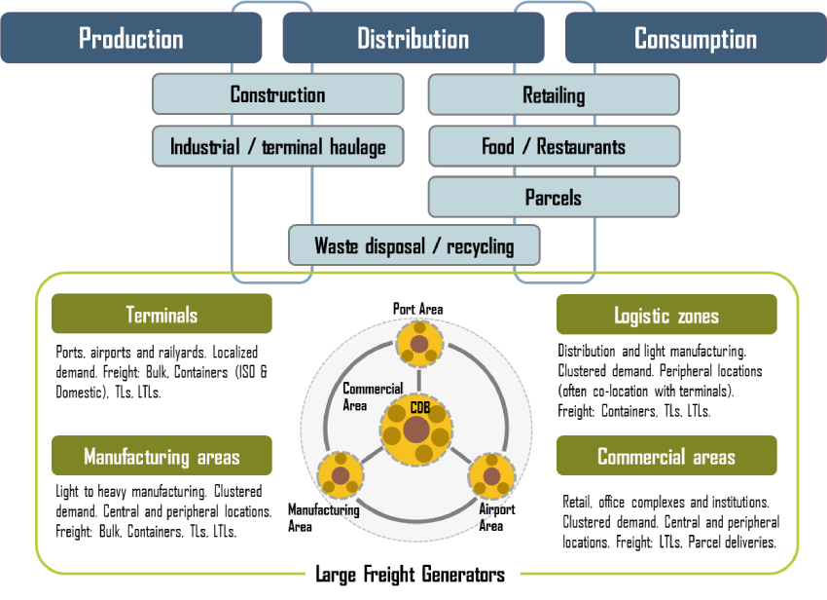City Functions and Urban Distribution The city is jointly a place of production, distribution and consumption of material goods and will thus generate material flows. The role and extent of these functions varies according to the historical and socioeconomic context of each city, commonly involving a specialization (e.g. financial cities, manufacturing cities). Globalization has changed the functions of production, consumption and particularly distribution by expanding its role with terminals and logistics zones. Some cities, namely global cities, have become prime financial, cultural, transportation and political centers, with production taking a more marginal role. With the growth of long distance trade, many cities also play an intermediary role with the port and airport facilities articulating the commercial flows of vast markets. For instance, gateway cities are the interface between global and regional freight distribution. The functions of consumption, production and distribution are associated with various types of material flows, each representing a form of city logistics. For instance, retailing relies on urban deliveries originating from distribution centers, which themselves are likely to have been supplied through terminal haulage. The intensity level of urban freight distribution is usually clustered around large specialized generators, which come in four major types:
- Terminals, such as ports, airports and railyards, are highly localized entities with access points often supporting high traffic levels. Since terminals handle a wide variety of freight, it can be expected that it will enter urban areas as bulk, containers, full truck loads (TLs) and less than truckload (LTLs). The market area of transport terminals is defined as the hinterland, which can involve destinations (logistics zones and manufacturing districts) within the city itself or flows having to transit through urban areas on their way to other destinations. The impact of a transport terminal on city logistics is obviously related to the intensity of the terminal activity, the supply chain it services and the extent of its hinterland.
- Logistics zones include warehouses, sometimes associated with clustered distribution and light manufacturing activities. Higher consumption levels and global supply chains have been a driving force in the setting and expansion of logistics zones. Co-location with a terminal facility has been a driving force, implying more efficient interactions because of proximity; freight has less propensity to enter urban areas. High land prices near terminals and central areas have also incited the development of greenfield logistics zones in peripheral areas, sometimes far away.
- Manufacturing districts. In the contemporary setting many production activities are related to global processes and elements of global value chains since they may produce finished goods, but more likely intermediate goods (e.g. parts). They are generators of producer-related urban freight movement involving all possible forms of road transport. Manufacturing districts are commonly found in association with transport terminals, particularly for heavy industry. Still, manufacturing and logistics activities are often mixed as pure manufacturing or logistics areas are rare; standard manufacturing activities are common in logistics areas. The distinction between a logistics and a manufacturing zone can thus on occasion be blurred. For instance, many logistics zones were developed as industrial zones that attracted distribution centers instead.
- Commercial districts. Core component of the urban centrality and the destination of the bulk of urban passenger flows. They concern consumer-related freight movements, mostly through retail activities usually supplied through LTLs (e.g. delivery vans and trucks). The clustering of office towers and large institutions (seats of government, universities, museums, etc.) is also a large generator of freight demand such as parcels. Some central business districts also involve adjacent freight intensive activities such as rail yards and even port terminals, particularly in older cities or in cities having an important gateway function. As cities are increasingly polycentric, several commercial districts such as urban subcenters have emerged.
Therefore, urban freight generators are commonly interrelated. For instance, a port district will involve maritime terminals but also nearby distribution centers and industrial activities. The same applies to airport districts that can experience a concentration of distribution centers and commercial activities.

9.THE GEOGRAPHY OF TRANSPORT SYSTEMS

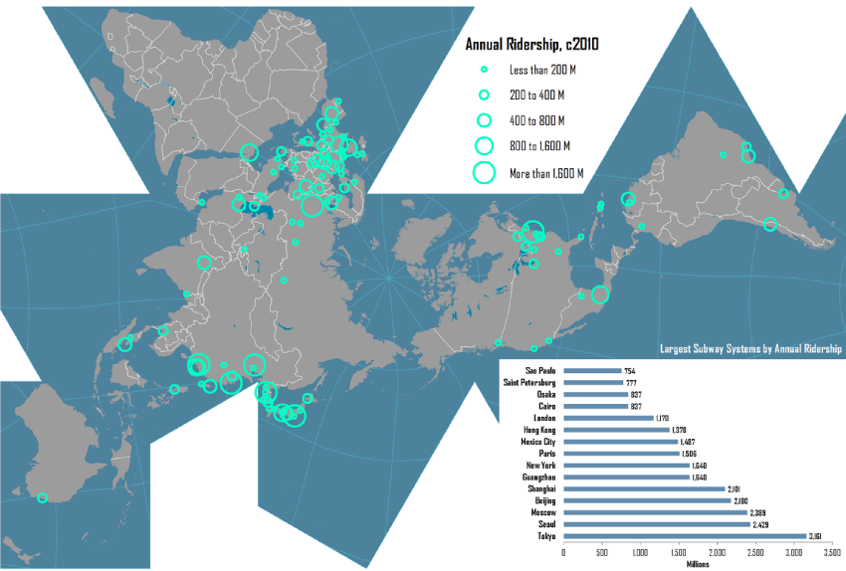
Source: adapted from Metrobits.org, World Metro Database.
(Detailed PDF Map) World's Main Subway Systems, c2010 There are approximately 184 subway (metro) systems in operation around the world, with several carrying more than 1 billion passengers per year. The construction and setting of subway systems has accelerated in recent years, particularly in cities in developing economies where mass transit becomes a clear strategy to improve urban mobility and mitigate congestion. The level of ridership is linked with several geographical and economic considerations. Some cities with high ridership such as Moscow, Beijing and Shanghai have a tradition of subsidized public transportation and transit-oriented urban planning. Many high-density cities have a level of subway ridership proportional to their population (London, Hong Kong, Osaka, Paris, Seoul and Tokyo) indicating a consistent level of ridership where public transit accounts between 25% and 50% of commuting. Cities where ridership is proportionally less than the population have either a significant portion of their population too poor to afford subway (Sao Paulo and Mexico), or wealthy enough to prefer the automobile (New York).

10. Inland Ports / Authors: Dr. Jean-Paul Rodrigue and Dr. Theo Notteboom 1. A New Role for Inland Terminals.

The evolution of inland freight distribution can be seen as a cycle in the ongoing developments of containerization and intermodal transportation. The geographical characteristics linked with modal availability, capacity and reliability of regional inland access have an important role to play in shaping this development. As maritime shipping networks and port terminal activities become better integrated, particularly through the symbiotic relationship between maritime shipping and port operations, the focus shifted on inland transportation and the inland terminal as a fundamental component of this strategy. Thus, after a phase that relied on the development of port terminals and maritime shipping networks, the integration of maritime and inland freight distribution systems has favored the setting of inland ports.
Inland port. A rail or a barge terminal that is linked to a maritime terminal with regular inland transport services. An inland port has a level of integration with the maritime terminal and supports a more efficient access to the inland market both for inbound and outbound traffic. This implies an array of related logistical activities linked with the terminal, such as distribution centers, depots for containers and chassis, warehouses and logistical service providers.
The Cold Chain and its Logistics Authors: Dr. Jean-Paul Rodrigue and Dr. Theo Notteboom Note: Sections of the text derived from Rodrigue, J-P (2014) Reefers in North American Cold Chain Logistics: Evidence from Western Canadian Supply Chains, The Van Horne Institute, University of Calgary.

. The Cold Chain While globalization has made the relative distance between regions of the world much smaller, the physical separation of these same regions is still a very important reality. The greater the physical separation, the more likely freight can be damaged in one of the complex transport operations involved. Some goods can be damaged by shocks while others can be damaged by undue temperature variations. For a range of goods labeled as perishables, particularly food (produces), their quality degrades with time since they maintain chemical reactions which rate can be mostly mitigated with lower temperatures. It takes time and coordination to efficiently move a shipment and every delay can have negative consequences, notably if this cargo is perishable. To ensure that cargo does not become damaged or compromised throughout this process, businesses in the pharmaceutical, medical and food industries are increasingly relying on the cold chain.
The cold chain involves the transportation of temperature sensitive products along a supply chain through thermal and refrigerated packaging methods and the logistical planning to protect the integrity of these shipments. There are several means in which cold chain products can be transported, including refrigerated trucks and railcars, refrigerated cargo ships as well as by air cargo.
The cold chain is thus a science, a technology and a process. It is a science since it requires the understanding of the chemical and biological processes linked with perishability. It is a technology since it relies on physical means to insure appropriate temperature conditions along the supply chain. It is a process since a series of tasks must be performed to prepare, store, transport and monitor temperature sensitive products. From an economic development perspective, the cold chain enables many developing countries to take part in the global perishable products market either as producers or as consumers. The growth in income is associated with a higher propensity to consume fruits, vegetables, fish and meat products. Increasing income levels create a change in diet with amongst others a growing demand for fresh fruit and higher value foodstuffs such as meat and fish. Persons with higher socioeconomic status are more likely to consume vegetables and fruit, particularly fresh, not only in higher quantities but also in greater variety. Consumers with increasing purchase power have become preoccupied with healthy eating, therefore producers and retailers have responded with an array of exotic fresh fruits originating from around the world. From a geographical perspective, the cold chain has the following impacts:
- Global. Specialization of agricultural functions permitting the transport of temperature sensitive food products to distant markets. Enables the distribution of vaccines and other pharmaceutical or biological products from single large facilities.
- Regional. Can support the specialization of production and economies of scale in distribution. This could involve large cold storage facilities servicing regional grocery markets or specialized laboratories exchanging temperature sensitive components.
- Local. Timely distribution to the final consumer of perishables, namely grocery stores and restaurants.
Some domestic or transnational supply chains may only require one transportation mode, but many times ground shipments are only one link in a combination of transport modes. This makes intermodal transfers critical for the cold chain. Intermodal shipments typically use either 20 or 40 foot refrigerated containers that are capable of holding up to 26 tons of food. The container makes loading and unloading periods shorter and less susceptible to damage both on the container and its cargo. The environments in these containers are controlled electronically by either plugging into a generator or power source on the ship or truck. The efficiency of cold chain logistics permitted the consolidation of cold storage facilities. 2. Emergence of Cold Chain Logistics While global commodity chains are fairly modern expansions in the transportation industry, the refrigerated movement of temperature sensitive goods is a practice that dates back to 1797 when British fishermen used natural ice to preserve their fish stock piles while at sea. This process was also seen in the late 1800s for the movement of food from rural areas to urban consumption markets, namely dairy products. Cold storage was also a key component of food trade between colonial powers and their colonies. For example, in the late 1870s and early 1880s, France was starting to receive large shipments of frozen meat and mutton carcasses from South America, while Great Britain imported frozen beef from Australia and pork and other meat from New Zealand. This process was incited by a shortage of meat production in Europe and substantial surpluses in developing countries. By 1910, 600,000 tons of frozen meat was being brought into Great Britain alone. The first reefer ship for the banana trade was introduced in 1902 by the United Food Company. This enabled the banana to move from an exotic fruit that had a small market because it arrived in markets too ripe, to one of the world's most consumed fruit. Its impacts on the reefer industry were monumental. The temperature controlled movement of pharmaceuticals and medical supplies is a much more recent activity than the shipping of refrigerated or frozen food. Since the 1950s, logistical third party companies began to emerge and institute new methods for successfully transporting these global commodities. Before their emergence, cold chain processes were mostly managed in house by the manufacturer. In the United States, Food and Drug Administration restrictions and accountability measures over the stability of the cold chain incited many of these companies to rely on specialty couriers rather than completely overhauling their supply chain facilities. Specialization has led many companies to not only rely on major shipping service providers such as the United Parcel Service (UPS) and Fedex, but also more focused industry that have developed a niche logistical expertise around the shipping of temperature sensitive products. The potential to understand local rules, customs and environmental conditions as well as an estimation of the length and time of a distribution route make them an important factor in global trade. As a result, the logistics industry is experiencing a growing level of specialization and segmentation of cold chain shipping in several potential niche markets within global commodity chains. Whole new segments of the distribution industry have been very active in taking advantage of the dual development of the spatial extension of supply chains supported by globalization and the significant variety of goods in circulation. The reliance on the cold chain continues to gain importance. Within the pharmaceutical industry for instance, the testing, production and movement of drugs relies heavily on controlled and uncompromised transfer of shipments. A large portion of the pharmaceutical products that move along the cold chain are in the experiment or developmental phase. Clinical research and trials is a major part of the industry that costs millions of dollars, but one that also experiences a failure rate of around 80%. According to the Healthcare Distribution Management Association about 10% of drugs are temperature sensitive. If these shipments should experience any unanticipated exposure to variant temperature levels, they run the risk of becoming ineffective or even harmful to patients. In all the supply chains it is concerned with, cold chain logistics favor higher levels of integration since maintaining temperature integrity requires a higher level of control of all the processes involved. It may even incite third party logistics providers to acquire elements of the supply chain where time and other performance factors are the most important, even farming. This may involve the acquisition of produce farms (e.g. orange groves) to insure supply reliability. Temperature control in the shipment of foodstuffs is a component of the industry that has continued to rise in relation with international trade. As a growing number of countries focus their export economy around food and produce production, the need to keep these products fresh for extended periods of time has gained in importance for commercial and health reasons. The cold chain is also a public health issue since the proper transport of food products will reduce the likeliness of bacterial, microbial and fungal contamination of the shipment. Also, the ability to transport medical goods over long distances enables more effective responses to healthcare issues (e.g. distribution of vaccines).

