Profesionālās izglītības kompetences centrs.
Kuldīgas tehnoloģiju un tūrisma tehnikums.
Autotransporta nodaļa
Priekšmets: Autoelektriķis
Pārbaudes darbs
Sagatavoja: Ēvalds Johansons

Vārds __________ Uzvārds _______________
Aprakstīt attēlā redzamo pieslēguma veidu, kādā auto mašīnā tas ievietots un kādas ir tā iespējas.
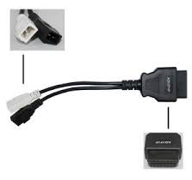
2P+2P_________________________________________________
______________________________________________________
________________________________________________________
________________________________________________________
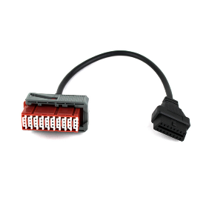
30P __________________________________________________
_____________________________________________________
_____________________________________________________
_____________________________________________________

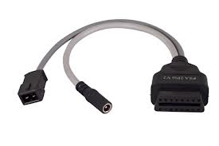
2P __________________________________________________
_____________________________________________________
_____________________________________________________
_____________________________________________________

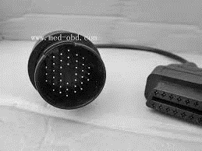
38P ________________________________________________
_____________________________________________________
_____________________________________________________
_____________________________________________________

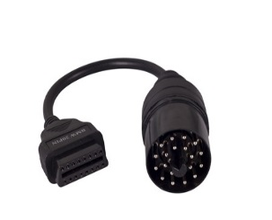
20P ____________________________________________________
_____________________________________________________
_____________________________________________________
_____________________________________________________

10P ___________________________________________________
_____________________________________________________
_____________________________________________________
_____________________________________________________
3P __________________________________________________
_____________________________________________________
_____________________________________________________
_____________________________________________________

