Izglītības programma: Restaurācija
Kvalifikācija: Restauratora asistents
Mācību priekšmets: Profesionālā angļu valoda
Skolotājs: D.Cine

Mācību materiāls:
Building construction ( resource: https://www.getty.edu/.../construction_building.html)
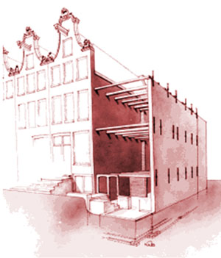
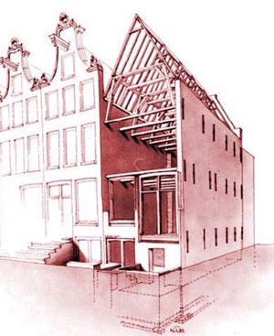
Since Amsterdam is located on a bog, houses are built on a typical foundation of wooden poles. Long wooden beams, basically entire trees of 13 to 20 meters long, were drilled into the soil to reach the firmer sediment layer of sand. The poles were placed in pairs, next to each other, with a distance of 80 cm between the pairs. The poles have to be kept under water to maintain an anaerobic environment and avoid rotting. The water levels in the city have therefore always been carefully maintained. Heavy foundation beams were nailed on top of the poles, which were first cut at the same level. These formed the basis for the house.
On top of these beams, several layers of stone were built with loam (in Dutch ‘leem’). 5 to 6 layers of bricks were laid on top with a tough mortar of sand, and lime, with the purpose of blocking rising damp.
Then the walls were built in brick (Amsterdam bricks were 18/19 x 9 x 4.3 cm), using lime mortar. Walls were either 1 or 1.5 bricks thick (i.e. 18/19 - 27/28 cm). The walls were built up to the first level, where pine beams were placed to create the floors. What is exceptional in this house is that the beams were placed vertically on their shorter side, rather then laying flat on their wider side. This is unusual for the time period. It was known that beams placed this way were stronger, but beams were usually placed flat, in order to have a minimal loss of height. The exposed wood inside was later painted with linseed oil based paint. The beam heads were covered with tar to avoid wood rot. At the beam heads, iron cross ties were placed to counteract the natural outward bending of the brick walls and to create a strong joint between beams and walls. When reaching the intended height of the outside walls, the wooden roof construction was built. Last but not least, the roof tiles were put in place. Lead lined gutters and downspouts are used to deal with precipitation.
Until 1570/1580, oak wood was the type of wood used in Amsterdam for building houses, but by the time this house was constructed, oak was becoming scares and expensive. Softwood (pine) from the Netherlands, but also imported, was then gradually introduced. In the 17th century, oak wood was still considered superior and was therefore used in parts that are visible, in this house e.g. in the windows of the sael. Construction elements were built using pine. Sometimes pine beams were used, which were covered with oak – this was done in the cassette ceiling in the sael.
The brick walls were not plastered on the outside. At the back of the houses on the Heintje Hoekssteeg is a small inner court – its outside walls are plastered. On the inside the walls were as normal in those days plastered with lime plaster. The original plaster survived in the sael.
https://www.getty.edu/.../construction_building.html
Iemācīties:
pole (peul) – pālis, baļķis
beam – baļķis
trunk – stumbrs
loam(leum) – māli(būvniecībai)
lime – kaļķsi
lime mortar ( mo:te) – kaļķu java
linseed oil – linsēklu eļļa
tile – dakstiņš
gutter – notekcaurule
downspout – notekcaurule
precipitation - nokrišņi

