Uzraksti vecās drukas tekstu mūsdienu rakstībā!
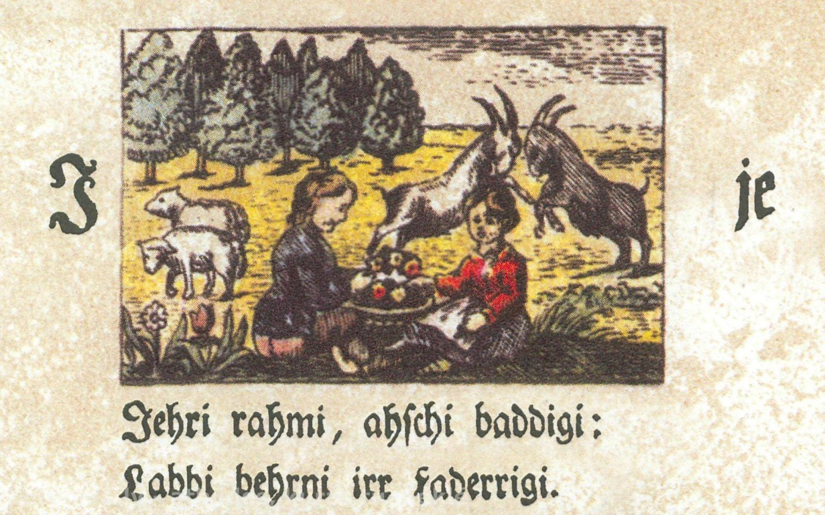
_________________________________________________________________________________________________________________
___________________________________________________________________________________________________________________
----------------------------------------------------------------------------------------------------------------------------------------------------------------------------------------------------------------
Uzraksti vecās drukas tekstu mūsdienu rakstībā!
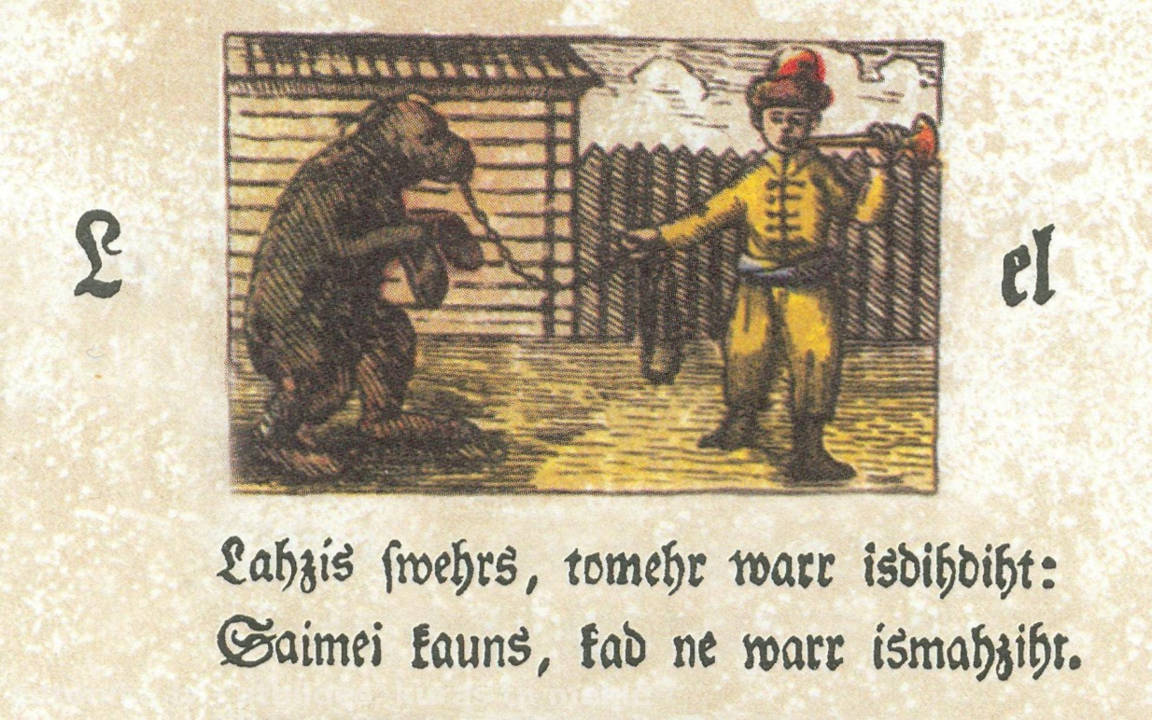
_________________________________________________________________________________________________________________
___________________________________________________________________________________________________________________

Uzraksti vecās drukas tekstu mūsdienu rakstībā!
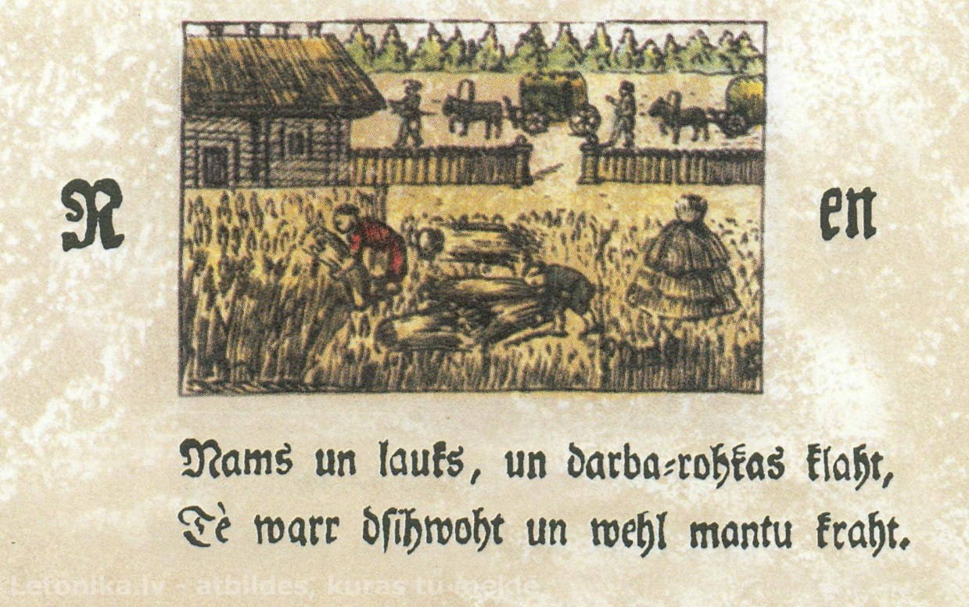
_________________________________________________________________________________________________________________
___________________________________________________________________________________________________________________
---------------------------------------------------------------------------------------------------------------------------------------------------------------------------------------------------------------

Uzraksti vecās drukas tekstu mūsdienu rakstībā!
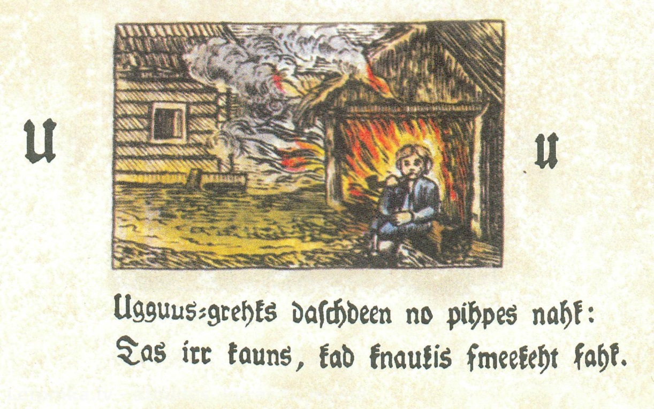
_________________________________________________________________________________________________________________
___________________________________________________________________________________________________________________
Uzraksti vecās drukas tekstu mūsdienu rakstībā!
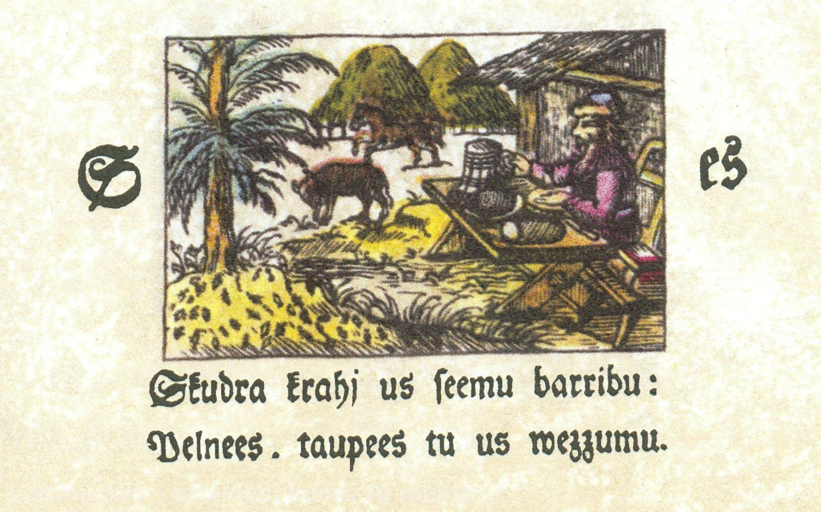
_________________________________________________________________________________________________________________
___________________________________________________________________________________________________________________
---------------------------------------------------------------------------------------------------------------------------------------------------------------------------------------------------------------

Uzraksti vecās drukas tekstu mūsdienu rakstībā!




