Kuldīgas tehnoloģiju un tūrisma tehnikums
Izglītības programma – Kokizstrādājumu izgatavošana
Kvalifikācija – mēbeļu galdnieks
Programmvadības (CNC) kokapstrādes darbmašīnu operācijas

Mārtiņš Mednieks

CNC tipa darbmašīnu griezējinstrumenti un aizsardzības, nomaiņa

kātfrēzes ar lodētiem HM asmeņiem

PSB6 - multicut router
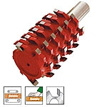

PSB3 - profil router with hole for fitting trimming cutter
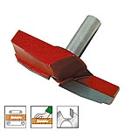

PSB4 - profil router with hole for fitting trimming cutter

PSB5 – tri mming cutter for artt. Psb3-psb4
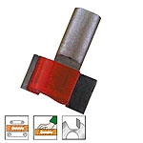

PSB1 - profil router (simple profile)
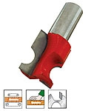

PSB2 - profil router (complexe profile)
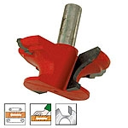

Kāta frēzes ar maināmiem reversīviem nažiem

TPP40 - groups for execution of doors

TPP41 - groups for profile and counter-profile of doors
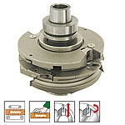

TPP42 - groups for profile and counter-profile of doors
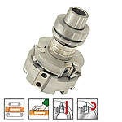

TPP43 - groupes for te squaring of doors
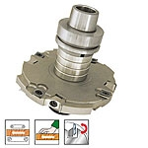

TPP37 - router bits with reversible knives
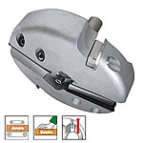

TPP38 - router bits ar atgriezēj nazi

TPP39 - groups for execution of "arch" windows

TPP34 - knife-holder bit for joints
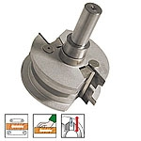

TPP35 - router bits with reversible knives
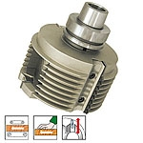

TPP36 - router bits with reversible knives

TPP31 - router bits with reversible knives
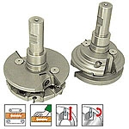

TPP32 - router bits with reversible knives
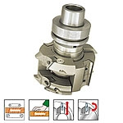

TPP33 - knife-holder bit for curved profiles
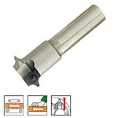

TPP28 - combined cutters for doors thickness sp 20/37

TPP29 - combined cutters for doors thickness sp 22/25

TPP30 - combined cutters for doors thickness sp 20/23,5

TPP26 - coupled bits for internal and external shaping of doors
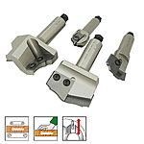

TPP27 - coupled bits for internal and external shaping of doors

TPP24 - router bits with reversible knives in hm with complex profile

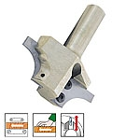

TPP25 - router bits with reversible knives in hm with special profile

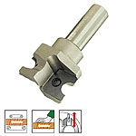

TPP21 - multiprofils cutterhead to execute internal shaped of pannels z=2
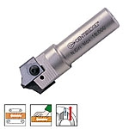

TPP22 - router bits with reversible knives

TPP23 - router bits with reversible knives
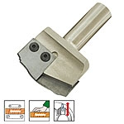

TPP18 - cutterheads for half circles

TPP19 - cutterheads for quarter circles

TPP20 - inclinde urbji noapaļošanas paneļi
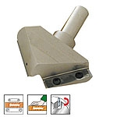
TPP13 - profilēšanas nažu turētājs bit
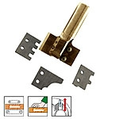

TPP14 - profiling knife-holder bit
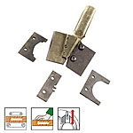

TPP15 - daudzprofilu frēze

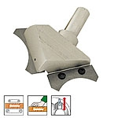

TPP16 - planer cutterhead z3
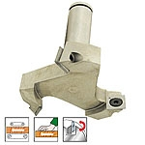

TPP17 - router bits with reversible knives
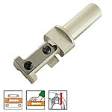

TPP10 - router bits with reversible knives
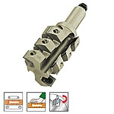

TPP11 - router bits with reversible knives
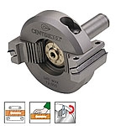

TPP12 - router bits with reversible knives
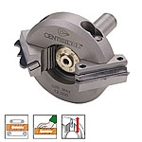

TPP7 - router bits with reversible knives
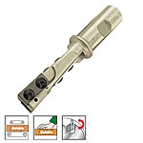

TPP8 - router bits with reversible knives
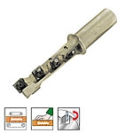

TPP9 - router bits with reversible knives
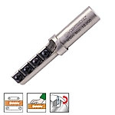

TPP0 - router bits with reversible knives
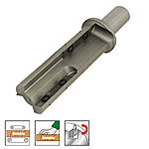

TPP1 - router bits with reversible knives
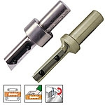

TPP2 - router bits with reversible knives
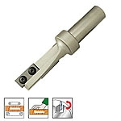

TPP3 - router bits with reversible knives
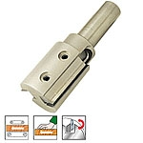

TPP4 - router bits with reversible knives
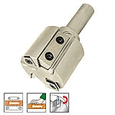

TPP5 - router bits with reversible knives
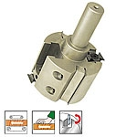

TPP6 - router bits with reversible knives
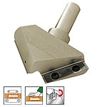

Masīva cietmetāla kātfrēzes CNC darbmašīnām

Solid carbide up and down router bit DIS.502
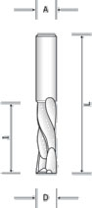

Solid carbide router bit for locks DIS.503

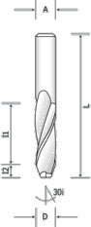

Solid carbide router bit for locks DIS.504
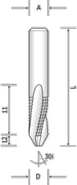

Solid carbide elicoidal router bit DIS.123
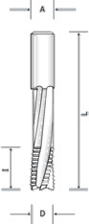
Cietā karbīda elicoidal Mortising griezējs DIS.124
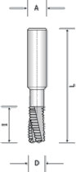
Cilindrisks instrumenta turētājs CNC mašīnām DIS.125
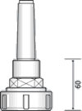

instrumenta turētājs CNC mašīnām DIS.127

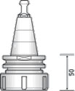

Collet holder for CNC machines DIS.128
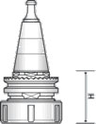

canga un gredzens DIS.140



Router bit DIS.101
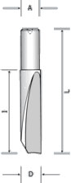

Router bit DIS.102
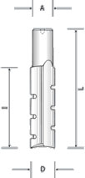

Router bit DIS.103
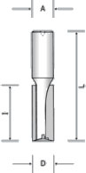

Router bit DIS.115
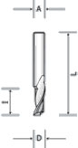

Router bit DIS.116
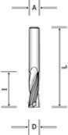

Router bit DIS.117
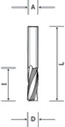

Router bit DIS.118
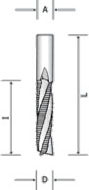

Solid carbide finishing router bit with negative twist DIS.120
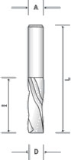

Solid carbide finishing router bit with negative twist DIS.121
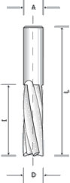

Cietā karbīda apdares router bit ar negatīvu vērpjot - ar DIS.122 chipbreaker
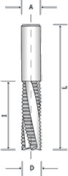

Solid carbide up and down router bit DIS.501
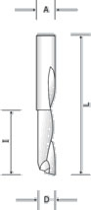

Dimanta instrumenti
Polikristālu dimanta cilindra spirālfrēzePolikristālu dimanta cilindra urbšanas bit DIS.412
DIS.412
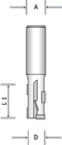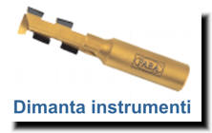
•

Kāta frēzes/Spirālfrēzes
Kategorija: Frēzes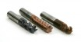
Ražotājs: Witec GmbH
HSS-Co8% (M42) ātrgriezējtērauda kāta frēzes tēraudu, čugunu, vara, vara sakausējumu, alumīnija, alumīnija sakausējumu, niķeļa sakausējumu un plastmasu apstrādei. Smalkgraudaina cietsakausējuma spirālfrēzes augstražīgam darbam CNC iekārtās.

Urbji
- 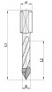

Caurejošie urbji
Kategorija: Urbji
- 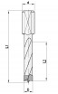

Necaurejošie urbji
Kategorija: Urbji
- 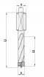

Necaurejošie urbji ar pagarinātu darba daļu
Kategorija: Urbji

- 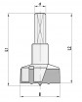

Eņģu urbji
Kategorija: Urbji
- 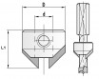

Zeņķurbji
Kategorija: Urbji
- 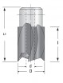

Cilindriskie gremdurbji
Kategorija: Urbji

